Center of Excellence starter kit

The Center of Excellence (COE) starter kit is a collection of components or tools that are designed to help get started with developing a strategy for adopting and supporting the Power Platform, with a focus on PowerApps and Flow.

# Contents

Contents 1

Motivation 3

Philosophy 4

Prerequisites 5

Scope 6

Components list 6

Common Data Service Entities 6

Environments 6

PowerApps Apps 6

Flows 6

Connectors 6

Connection References 6

Makers 6

Audit Logs 6

COE Settings 7

Flows 7

Admin | Sync 7

Admin | Sync Audit Logs 7

Admin | Welcome Email 7

Admin | Compliance detail request 7

Canvas Apps 8

Developer Compliance Center 8

App Catalog 8

DLP Editor 8

Model Driven Apps 9

Power BI Report 10

Security Roles 10

Power Platform Admin SR 10

Power Platform Maker SR 10

Power Platform User SR 10

Business Process Flows 10

PowerApps App Approval BPF 10

Example Processes 11

PowerApps App Auditing Process 11

Limitations 12

Setup Instructions 13

Prerequisites 13

Step 1: Install the Common Data Service solution 13

Components covered 13

Dependent on 13

Dependencies 13

Description 13

Instructions 13

Grant access to end users 15

Step 2: Configure COE Settings 19

Components covered 19

Dependent on 19

Dependencies 19

Description 19

Instructions 19

Step 3: Install the Flows 20

Components covered 20

Dependent on 20

Dependencies 20

Description 20

Instructions 21

Step 4: Configure the Power BI Dashboard 24

Instructions 24

Step 5: Setup Audit Log sync 26

Components covered 26

Depends on 26

Dependencies 26

Instructions 26

# Motivation

PowerApps and Flow have drastically matured as a platform over the past couple of years. When it was first announced and gained popularity, there was more focus on understanding and adjusting to the nature of the product and how it could best be utilized on an individual level. Nowadays, PowerApps and Flow has achieved much more widespread adoption, and it’s no longer a question of how or whether to use the platform—companies are now looking to understand how to scale adoption throughout their own organizations in a maintainable way to fully benefit from it. Since the Power Platform is a unique type of product, it might be unfamiliar to administrators who want to achieve the latter goal of creating a scalable strategy to adopt and support PowerApps and Flow in their organization.

Developing a Power Platform Center of Excellence is a high-level goal, which means there is some focused entity that manages and supports the platform. We often hear that companies wish to develop their own COE because having this entity provides evidence of a mature approach to utilizing PowerApps and Flow. There are multiple responsibilities of an established COE, and it’s up to each organization to figure out how they decide to define parameters for those responsibilities. These responsibilities can be segmented into the following four categories.

1. **Administration & Governance**
   1. Secure
   2. Monitor
   3. Alert and Action
2. **Nurture**
   1. Evangelism and Training
   2. Technical Guidance
   3. Tools and Components
3. **Operations**
   1. Application Lifecycle Management
   2. Infrastructure automations
4. **Support**

The Center of Excellence should consider the way they choose to address each of these responsibilities. For example, what can your organization do to promote Evangelism and Training of PowerApps and Flow? How does the COE adequately Monitor the activity in the organization? What are the security requirements for the organization, and how are they being implemented? Although these responsibilities might be broken up between different business units within the same organization, they need to be addressed and ideally documented.

The main reason for developing a COE starter kit was to convey the concept of what a COE might need to do, while giving an example of how to address some of these requirements. The kit is just a template that might not match every organization’s requirements, so it’s recommended that you extend the solution to fit your organization’s requirements defined by your COE.

# Philosophy

A Power Platform Center of Excellence is an entity that should take ownership of PowerApps and Flow support and is best executed if the people involved plan a strategy around pre-defined processes and shared goals. Part of this strategy will require some interaction with the platform resources directly, and it’s good to understand where and how to interact with the platform in those situations.

Example: Contoso organization decides that administrators should have complete control over the Environment creation in their tenant, to avoid unaccounted consumption of database capacity. There are multiple ways to implement a process to meet this requirement, and each way can use different categories of implementation.

Follow this process when thinking about the medium in which a Center of Excellence strategy should be executed:

**Out-of-box product.** The core, most important capabilities for admins and makers exist in the supported product portal features (e.g., PowerApps & Flow maker portals and admin portals). These features are designed to be the easiest and most robust way to complete tasks. For example, Environment and DLP Policy creation can be executed in the PowerApps and Flow admin centers.

In the Contoso example, their Environment creation process could be managed through email requests, and administrators manually create the Environments. They would need to understand that Environments can be created in the PowerApps and Flow admin centers, which are considered out-of-box features that are fully supported by the product team.

**Platform extensions.** There are four standard connectors that provide access to the same APIs that the out-of-box product use. These have been exposed through the connectors library to give users the ability to create custom solutions to execute administrative or governance related tasks.

Admin connectors:

* Power Platform for Admins
* PowerApps for Admins
* Flow Management
* PowerApps for App Makers

Coming back to the Contoso example, the Environment creation process can be automated using the admin connectors to create Environments with Flow, based on a request submitted to some database through an interface designed by the Center of Excellence team. This might take some more initial configuration to design and implement, but it will benefit the administrators because they would no longer be required to spend time navigating to the admin portals and manually entering in the user’s requested information. Since the solution is a custom implementation (e.g., a Flow), the solution itself is not supported by the product group but the correct functionality of the connectors and API will be.

This path also represents a feedback loop that can be used to help develop the product. First, users should look to the out-of-box solution that is provided from the product team. If that is not sufficient, they can use extensions to achieve their goals, and could potentially be additions to the product in the future if enough people need it. That paradigm can also be seen in the COE starter kit itself—it may or may not have all the features you are looking for from the start, but we plan to iterate on the solution and can develop the templates in areas that are needed.

**Templates & customizations.** The COE starter kit falls into this category, which is a set of templates that use the admin connectors in combination with other connectors and formulas to achieve some specified goal. The nature of a template is to provide a good solution for that specific task, but it might not have the exact functionality that everyone needs and could require adjustment to achieve what others might be looking for. It is better to first explore the other two options before instantiating a template, unless it’s clear that the template has everything you need from the start.

If our Contoso admins came across a template that implements a process for Environment creation, they would need to consider if the template matches the process they are looking for or if they’re willing to adopt the solution it presents instead. If not, they might have to make adjustments to the template to fit their process. Because not all templates are supported by the product group (e.g., found on the community channel), there’s no guarantee that it will meet expectations defined. Therefore, it’s recommended to first explore the more supported platform features before looking to templates.

# Prerequisites

The following are prerequisites for installing the COE starter kit as it comes in the solution.

1. Admin account (global tenant admin, BAP admin or Power Platform service admin) for access to all tenant resources. This solution will still work for Environment admins, but the view will be restricted.
2. PowerApps Plan 2 (or trial)
3. Environment with a CDS for Apps instance provisioned, where the user installing the solution has System Administrator security role.
4. Download of the Center of Excellence Solution and Power BI dashboard files to your device

These are the requirements for using the solution.

1. **Admin**: PowerApps Plan 2 (or trial) + assigned the Power Platform Admin SR + Audit Log access.
2. **Maker**: PowerApps Plan 1 + assigned the Power Platform Maker SR
3. **User**: PowerApps Plan 1 + assigned the Power Platform User SR

Note: Instructions to grant access and assign security roles can be found in the Setup Instructions section.

# Scope

The COE starter kit is a set of tools to help a company get started with adopting the Power Platform, because it contains patterns and a solution structure that helps manage resources and information about those resources.

However, the kit does not represent the entire Center of Excellence, because there is much more to a Center of Excellence than the tools alone; the Center of Excellence also requires people, communication, defined requirements and processes. The tools provided here are just a means to get to the end goal, but the Center of Excellence itself must be thoughtfully designed by each organization based on their needs and preferences.

# Components list

List of components included in the COE starter kit. Some are included in the solution package, and others live just outside of the package.

## Common Data Service Entities

These entities are defined in the solution package.

Note: Where the data comes from? The Flow called “Admin | Sync Template” iterates through the resources in the tenant (Environments, Apps, Flows, Connectors) using the admin connectors.

### Environments

Represents the Environment object, which contains PowerApps, Flows and Connectors.

### PowerApps Apps

Represents a PowerApps App.

### Flows

Represents a Flow.

### Connectors

Represents a standard or custom connector.

### Connection References

Represents a connection used in a PowerApp or Flow.

### Makers

Represents a user who has created a PowerApp, Flow, Custom Connector or Environment.

### Audit Logs

Represents session details for PowerApps.

#### Where the data comes from

The Office 365 Audit Logs. The custom connector included in the kit will provide programmatic access to these logs, and the Flow called ‘Sync | Audit Logs’ will populate this entity.

### COE Settings

Settings configurations live in a record here. This is an important entity to populate data into during the setup process, because it contains details that are important for configuring the branding and support aspect of the solution



## Flows

List of Flows that come with the solution.

### Admin | Sync

“Uber” sync Flow that syncs resource data from the admin connectors to the CDS resource entities.

### Admin | Sync Audit Logs

Uses the Office 365 Audit logs custom connector to write audit log data into the CDS Audit Log entity. This will generate a view of usage for PowerApps.

### Admin | Welcome Email

Sends an email to a user who creates a PowerApp, Flow, Custom Connector or Environment

### Admin | Compliance detail request

Sends an email to users who have PowerApps apps in the tenant who are not compliant with specific thresholds:

* The app is shared with > 20 Users or at least 1 group and the business justification details have not been provided.
* The app has business justification details provided but has not been published in 60 days or is missing a description.
* The app has business justification details provided and has indicated high business impact, and has not submitted a mitigation plan to the attachments field.

The Flow has a template you can customize in the email sent out by the Flow, but will otherwise look like the following:

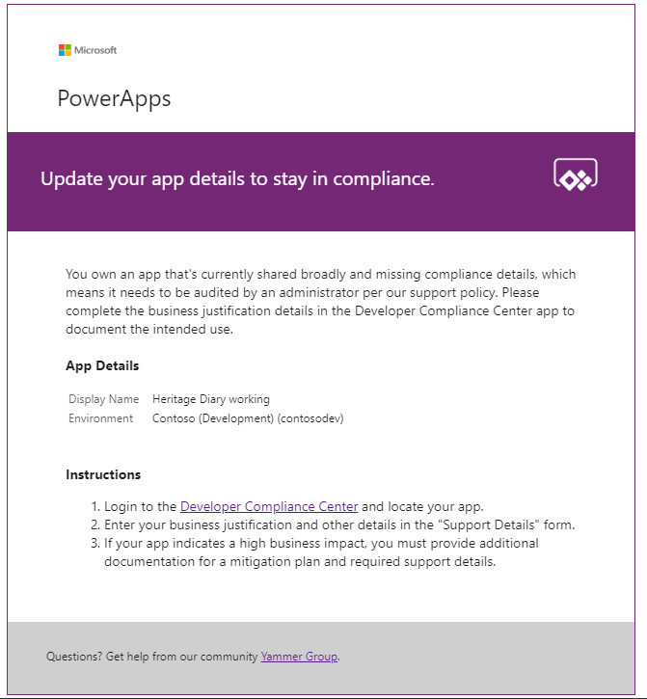

## Canvas Apps

### Developer Compliance Center

This app is used in the PowerApps App Auditing Process as a tool for users to create and

### App Catalog

Canvas app that gives access to the entire organization to make apps more discoverable. Admins audit and validate certain apps which are graduated to the app catalog if the app is meant to be shared broadly.

### DLP Editor

Canvas app that reads and updates DLP policies while showing a list of apps that are affected by the policy configurations.

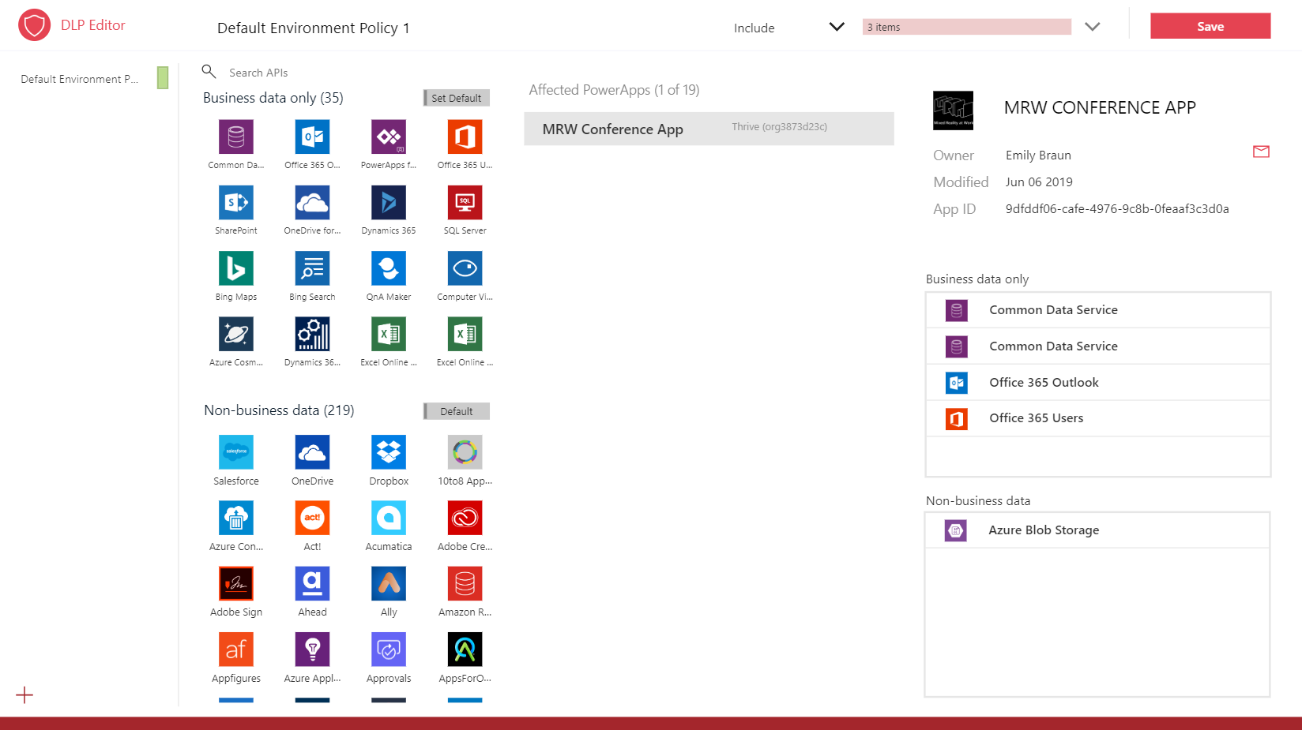

## Model Driven Apps

Power Platform Admin View. A model driven app that provides an interface used to navigate the items in the CDS custom entities. It provides access to views and forms for the custom entities in the solution.

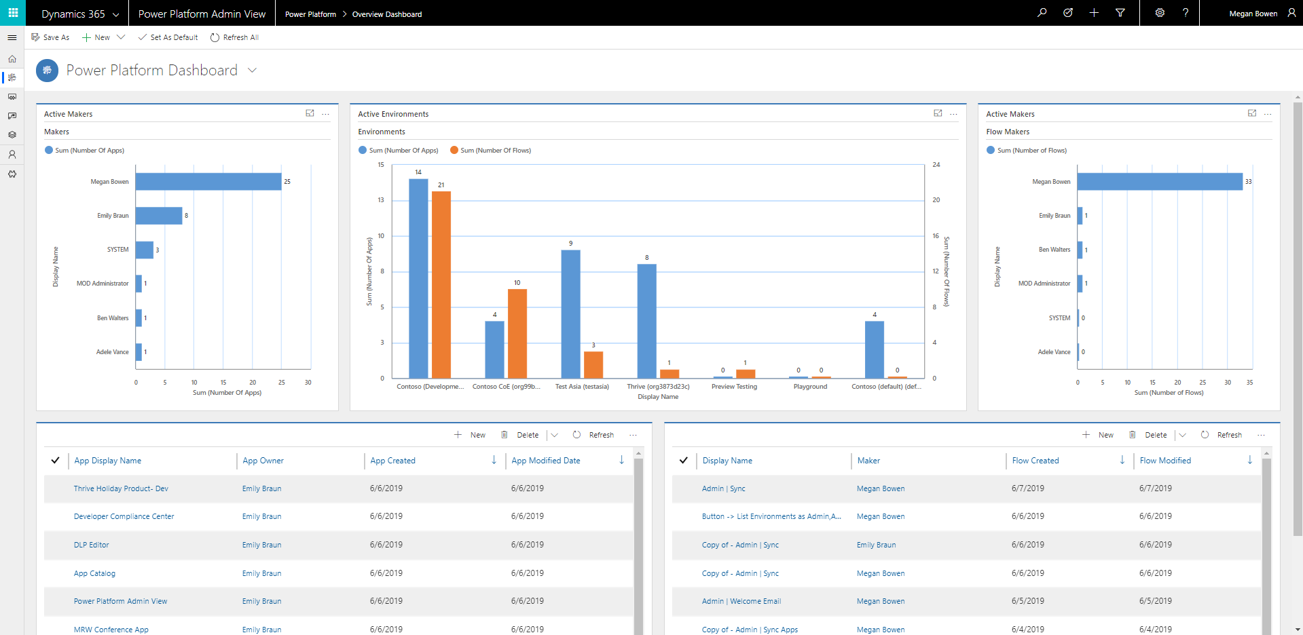

## Power BI Report

Provides a wholistic view with visualizations and insights of data in the CDS entities: Environments, PowerApps Apps, Flows, Connectors, Connection References, Makers and Audit Logs.

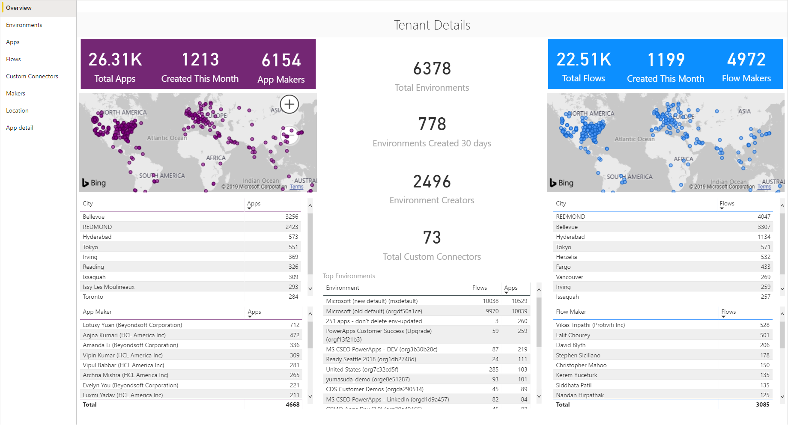

## Security Roles

### Power Platform Admin SR

Gives full access to create, read, write and delete operations on the custom entities.

### Power Platform Maker SR

Gives read and write access to the resource custom entities.

### Power Platform User SR

Gives read only access to the resources in the custom entities.

## Business Process Flows

### PowerApps App Approval BPF

This process helps the admin audit the PowerApps App audit process by providing a visual placeholder for the stage in the process they are currently on.

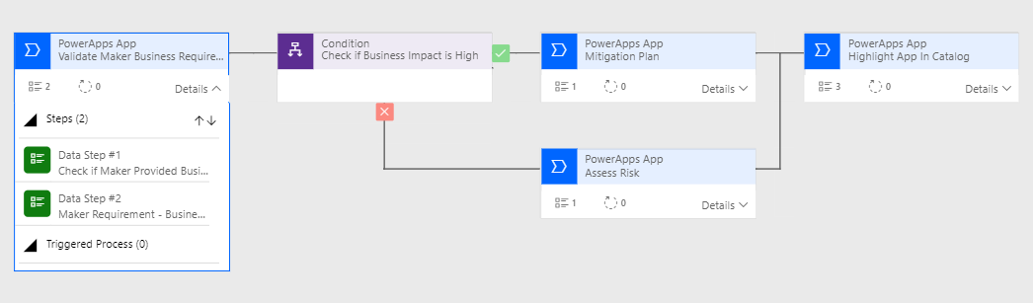  
Screenshot: An implementation of an auditing process using a Business Process Flow component

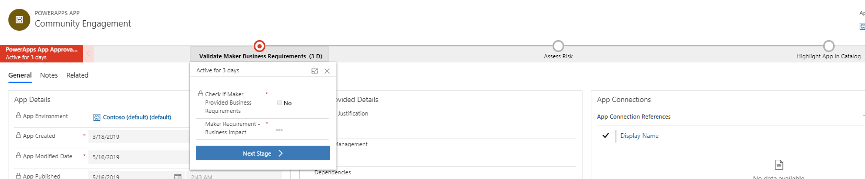

Screenshot: The BPF view while playing the model driven app, on the App form.

# Example Processes

The components listed above are designed for multiple uses, including an implementation of some the example processes. These are meant to showcase common patterns that exist, and hopefully act as inspiration on how to define your own processes to manage.

## PowerApps App Auditing Process

Problem statement: There are many apps in the Contoso tenant. IT does not know what all these apps are intended for, how to support individual apps when the helpdesk is called, and it’s unclear if all the apps are being maintained to any standard. They can see details like the description and number of shared users from the PowerApps for Admins connector, but they need to communicate directly with the app owner to fully understand the situation around their apps. Especially in a large organization like Contoso, it’s not feasible for the IT team to be responsible for manually reaching out to each owner individually for the apps, and those details cannot be stored in email conversations.

Solution: The COE has decided there should be an auditing process on an app-level basis, using the CDS as a data store for business justification details. They decide to use apps and Flows built around the data to facilitate this process.

The Flow called ‘Admin | Compliance detail request’ is used to iterate through all the apps in the tenant and check if the apps are compliant. If the owner has not submitted a business justification and the app was indicated to have been shared broadly (in this example, with more than 20 users or at least 1 group), then the Flow will send the owner an email to notify them that the specific app is not compliant with the company’s policy. The email contains a link to the Developer Compliance Center canvas app where they can provide the business justification details in a form submission. The app also contains details about the compliance thresholds and has links to the app settings so they can configure the description and re-publish if needed.

Once the maker has proven compliance by adding these details, the admin can review those details and the app itself. A business process flow in the Power Platform Admin View (model driven app) helps facilitate the auditing process. If the user has



# Limitations

There is no ‘one size fits all’ solution for a Center of Excellence. Some companies will want a very restrictive set of rules on their organization in the mind-frame of mitigating the unknown, while others will want to let users personally explore without limitations. Because of this, the COE starter kit does not come equipped with a set of design patterns for everyone. For example, there are no components that are configured to automatically delete resources, because we did not want to provide a tool that might have unintentionally disrupted a business when installed. Therefore, if more restrictive implementations are desired, it must be implemented in addition to these tools.

# Setup Instructions

There are multiple components provided in this starter kit, and each part will require some configuration to be installed in your tenant. The installation instructions have been segmented based on the set of components that should be grouped and installed together, and dependencies on other segments are outlined in each section. You may choose to exclude some components if you only want a subset of the functionality.

## Prerequisites

1. Admin account (global tenant admin, BAP admin or Power Platform service admin) for access to all tenant resources. This solution will still work for Environment admins, but the view will be restricted.
2. PowerApps Plan 2 (or trial)
3. Environment with a CDS for Apps instance provisioned (installer requires System Administrator security role)
4. Download of the Center of Excellence Solution and Power BI dashboard files to your device

## Step 1: Install the Common Data Service solution

### Components covered

* Entities
* Model Driven App
* Canvas Apps
* Security Roles

### Dependent on

Configure COE Settings. Make sure that the COE Settings are completed for the Canvas Apps installed in the solution to work correctly.

### Dependencies

All other segments listed below.

### Description

This is the first setup step and is required for any other component in the starter kit to work.

### Instructions

1. Go to the Environment where the solution will be installed
   1. Go to <https://make.powerapps.com>
   2. Navigate to the Environment the CoE solution will be hosted in. In the screenshots example, we're importing to the Environment called 'Contoso CoE'.
2. Select Solutions on the left navigation bar.

PowerApps 
I Home 
Learn 
Apps 
+ Create 
Data 
Entities 
Option Sets 
Data Integration 
Connections 
Custom Connectors 
Gateways 
Flows 
Solutions 
Build business apps, fast 
Create apps that connect to your data and work across web and mobile. Learn about PowerApps 
Make your own app 
Canvas app from blank 
Z Canvas app 
Model-driven app from blank 
Model-driven app 
Recent apps 
Shared with me 
Name 
Developer Compliance Center 
DLP Editor 
App Catalog 
Power Platform Admin View 
Start from data 
Z Canvas app 
Modified 
49 min ago 
49 min ago 
49 min ago 
49 min ago 
200. 
Owner 
You 
You 
You 
Megan Bowen 
Environment 
Contoso Center of Excellence 
Contoso (default) (default) 
Contoso (Development) 
(contosodev) 
Contoso Center of Excellence 
(org99b2e579) 
Playground 
Test Asia (testasia) 
PowerApps Training for Office 
Z Canvas app 
All templates -+ 
Type 
Canvas 
Canvas 
Canvas 
Model-driven 
AILapps 

1. Select **Import**, and a pop-up window will appear (make sure to disable the pop-up blocker in your browser and try again if nothing happens when clicking the Import button).
2. In the pop-up window, select **Choose File**.  
   Import Solution - Google Chrome 
   https://org99b2e579.crm.dynamics.com/tools/solution/import/SolutionlmportWi... 
   Select Solution Package 
   Select the compressed (Zip or cab) file that contains the solution you Want to 
   i In rt and Click Next. 
   Choose File o file chosen 
   Help 
3. Choose the **Power Platform** solution from the file explorer.

Note: If you would like to import the solution and want the ability to modify the configurations of the solution, import the **Unmanaged** version. If you do not need to modify the solution and just want to use it the way it comes, import the **Managed** version.

1. When the solution compressed (.zip) file has been loaded, click **Next**.
2. Review, click **Next**, then click **Import**. (This can take some time.)
3. When the import succeeds, the list of the components that were imported is displayed.

Note: Sometimes Flow components show a warning message and a duplicate record of that component

1. Click **Publish All Customizations**. This is good practice to follow whenever you make changes to a solution, but especially so when importing.

### Grant access to end users

The user account who uploaded the solution and the Environment admin of the Environment the solution exists in will have full access to the solution. To share this solution with others, there are some steps needed to configure access.

There are multiple components that must be shared with the end users. The components that must be configured for sharing include:

1. Environment, Solution, Model Driven App, Custom Entities require Security role assignments to be shared. Security groups can manage assignment of security roles to users.
2. Canvas Apps require shared permissions on an individual basis or through a Security group

Note: Security groups can be used to share a security role with multiple people in one action.

#### Share with Security Groups

You can share both security roles and canvas apps through security groups. Make sure the following prerequisites are met:

* Security group for end users (e.g., *Power Platform Makers SG*)
* The Power Platform Admin solution is already imported

Once the security group is configured:

1. Navigate to the Center of Excellence Solution
   1. Go to <https://make.powerapps.com> and set the current Environment to the same Environment where the Center of Excellence solution is installed
   2. Click **Solutions** > **Center of Excellence**
2. Select the ellipse (…) menu of the **Developer Compliance Center** canvas app > **Share**.  
   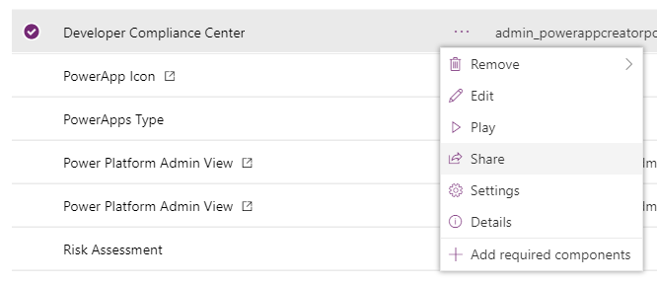
3. In the flyout, search for the security group by name  
   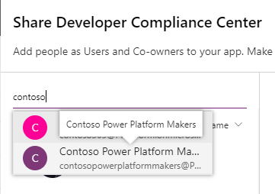
4. When the security group is selected, the Data permissions section on the lower right side of the flyout will populate with details on the connectors.   
   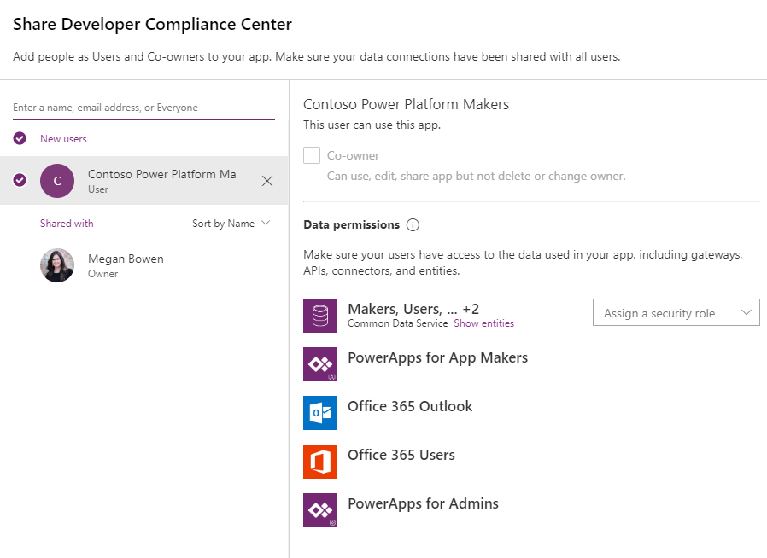
5. Next to the Common Data Service connector, click the combo box that says **Assign a security role**
6. Select the desired role (e.g. Power Platform Maker SR)  
   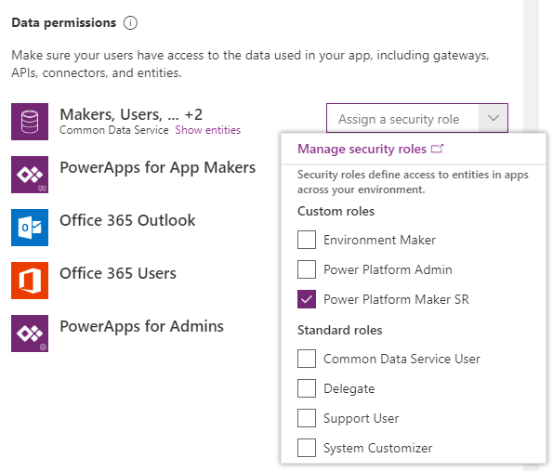
7. Optionally uncheck the “Send an email invitation to new users”, then click **Share.**

Note: The security roles will be assigned to each user in the security group, and the security group will continue to manage user assignment to the security role (e.g., when a user leaves the SG, they will no longer have the security role assigned to them unless they were individually assigned the role).

1. Repeat these steps for the **App Catalog** canvas app. Create a different SG that contains the entire organization and is assigned to the Power Platform User SR.

#### Sharing with Individual Users

Follow the steps in the section above, but search for an individual user account instead of the security group. The steps after selecting the user record will be the same.

#### Sharing with Individual Users (without Canvas)

The solution can be shared on an individual basis if desired, but it’s recommended that you use security groups to share the solution with end users to make access management more maintainable. This section does not share the canvas apps with individual users, in case the canvas app solution is not desired.

1. Navigate to the solution’s Environment security
   1. Go to <https://admin.powerapps.com>.
   2. Select the Environment with the Power Platform Admin solution installed.
   3. Click on the **Security** tab.

PowerApps 
Environments 
Data policies 
Data integration 
Tenant 
Admin center 
Environments 
NAME A 
Contoso (default) (default) 
Contoso (Development) (contosodev) 
Contoso CoE (org99b2e579) 
Playground 
Preview Testing 
Test Asia (testasia) 
TYPE 
Default 
Sandbox 
Production 
Production 
Production 
Trial (17 days) 
Search 
REGION 
United States 
United States 
United States 
Preview (United States) 
Preview (United States) 
New environment 
CREATED BY 
SYSTEM 
Megan Bowen 
Megan Bowen 
Megan Bowen 
MOD Administrator 
Megan Bowen 
CREATED 
02/28/2019 
03/18/2019 
06/02/2019 
04/1 5/2019 
04/22/2019 
05/20/2019 

1. Here, you can add individual sync users to the CDS instance's Users table if they are not already available. If you had created a new Environment for this solution, you will likely need to do this to give other accounts access to the solution.

PowerApps 
Environments 
Data policies 
Data integration 
Tenant 
Admin center 
Contoso CoE (org99b2e579) 
Details 
Security 
Resources 
Security model has changed in PowerApps and is now managed in Dynamics 365 user management center. Learn More 
Step 1: Add user [Preview] 
View the list of users in the environment. If you don't find a user from your organization, add a user. Functionality to add a user is in preview. 
Enter email address of the user in your organization (e.g.john@contoso.com) 
Add user 
Step 2: Assign security roles 
From the list of enabled users, you can select one or more users and assign security roles as appropriate. 
O The Environment Admin role is now called System Administrator. All existing role assignments were updated 
automatically. 
Assign security roles 

1. Click on **Assign Security Roles** to view the Users table.
2. In the Users table, select records by checking the check box to the left of each User's name. You can use the search bar at the top right to filter the table by name or email.

+ NEW 
o 
EDIT % APPROVE EMAIL 
Enabled Users v 
Full Name 
Ben Walters 
Megan Bowen 
REJECT EMAIL 
PROMOTE TO ADMIN 
Business Unit 
ug99b2e579 
org99b2e579 
MANAGE ROLES 
Title 
VP Sales 
CHANGE BUSINESS UNIT 
CHANGE M, 
Position 
Main Phone 
+1 732 555 0. . 

1. With the Users selected, click on **Manage Roles** at the top.
2. Select the checkboxes next to thedesiredsecurity role. This security role was provided in the solution and only gives read and write access to the custom entities in the solution. Click **OK**.

Manage User Roles 
What roles would you like to apply to the 1 User you have selected? 
Role Name 
Common Data Service user 
Delegate 
Erwironment Maker 
Platform Admin SR 
System Administrator 
System Customizer 
Business unit 
org99b2e579 
org99b2e579 
org99b2e579 
Org99b2e579 
org99b2e579 
org99b2e579 

1. At this point, the individuals who you have assigned to the Security Role to will have access to the data in the custom entities and model driven app that comes in the solution.

Note: This process can also be followed with the intention of sharing Power Platform Admin SR access to the CDS entities. This security role will give more control over full CRUD operations on the data and might make more sense to grant on an individual basis than end users.

#### Sharing with Security groups (without canvas)

Please read [this article](https://cloudblogs.microsoft.com/dynamics365/it/2019/05/01/using-azure-active-directory-groups-to-manage-an-users-app-and-data-access/) to share the solution without sharing the canvas apps.

## Step 2: Configure COE Settings

### Components covered

* ‘COE Settings’ data

### Dependent on

Install the Common Data Service Solution. The entity must be installed before we can write data to it.

### Dependencies

* **Canvas Apps**. The optional branding details (e.g., logo, brand colors) in all the canvas apps are pulled from this entity. Optional support and community channel links are also used.
* **Optional Flows**. The optional branding details and support channel links are used in the Flows used for communication. You also will configure links to the canvas apps in the settings. The main Flow that syncs data to the resource entities do not depend on this setting configuration.

### Description

This section explains how to enter data in this entity, which represents the settings for other components in the solution. It should be completed second.

### Instructions

1. Open the Power Platform Admin View model driven app.
2. In the left navigation, click on Settings
3. In the Settings view screen, click on “+ New” to create a new record
4. Provide values for each field.
5. Save by clicking CTRL + S or by clicking the Save button in the bottom right corner.
6. Do not add more records to this table, there is no need. The dependent components will always get values from the first record so there only needs to be one record in this table.

## Step 3: Install the Flows

### Components covered

Flows

### Dependent on

* Step 1: Install the CDS Solution
* Step 2: Configure COE Settings

### Dependencies

The ‘Sync’ Flows are used to write data from the admin connectors into the CDS entities.

### Description

This step should be completed after the first two steps above. The Flows with the prefix ‘Sync’ are required for populating data in the ‘resource’ related CDS entities (Environments, PowerApps Apps, Flows, Connectors and Makers).

There are multiple ways to import these Flows, and not all the Flows are required. Please read the description of each Flow to understand which ones are required and how to import it.

Required Flow to sync data to the resource entities:

1. **Uber Sync Flow (Admin | Sync)**  
   Flow type: Scheduled (daily by default)  
   Description: This is a single Flow that syncs data to all the resource related entities in one Flow. It’s part of the solution that was imported in the first step. This is the fastest to install, but it takes longer to execute.

Optional Flows. The other Flows available to import are not required to sync data into the resource entities but are recommended for the example audit process to work.

1. **Flow | Welcome Email**  
   Flow type: Automated  
   Description: When a Maker is added to the Makers table, it will add the user to a specified office group and send a welcome email to that user.
2. **Flow | Compliance notification email**  
   Flow type: Scheduled (weekly by default)  
   Description: The Flow iterates through the PowerApps apps in the CDS entity and checks for specific thresholds, then emails the app owner how they can stay compliant:   
   (a) If an app is shared with >20 users or >0 groups and the user has not submitted business requirements.  
   (b) If an app has submitted business requirements but has not been updated or missing a description.
3. **Flow | Sync Audit Logs**  
   Do not install this Audit Log Flow yet. This will be covered in the Audit Logs setup instructions, because it has additional requirements.

### Instructions

The Flows are all stored in the solution. It is automatically available in the Environment when you import the solution, but there are two options to consider. Option 1 takes longer to configure than option 2 but is also easier to receive updates.

#### Option 1: Keep Flow in the solution and update each action connection

Use this option if you would like to continue receiving updates to the Flow through this solution. This takes longer to set up because the connections for each action need to be individually configured.

1. Go to the Center of Excellence solution.
   1. Navigate to <https://make.powerapps.com> and set the current Environment to the same Environment where the Center of Excellence solution is installed
   2. In the left navigation, click on **Solutions**, then select the **Center of Excellence** solution
2. Click on the ellipse (…) menu next to the Flow you want to enable, then click **Edit**

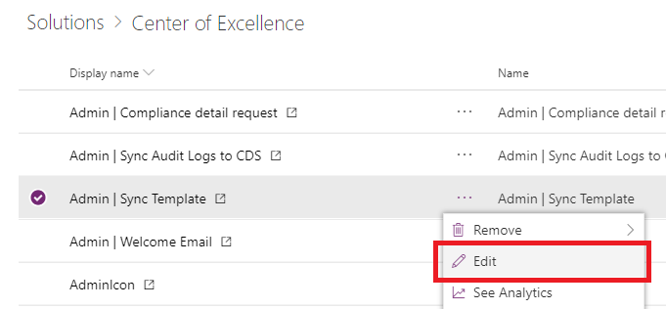

1. The Flow will open in the maker studio. For each action that requires a connection, there will be a warning icon on the right side of the action. This indicates the need for a connection to be selected.
   1. Some connections will need to be created if there are not available
   2. Some actions might be hidden within other built in actions, such as a condition or scope. Expand these actions to find the hidden ones so
2. Once all actions have a connection, save the Flow. It should run automatically for the first time if it’s a scheduled or manual Flow.

#### Option 2: Save a copy of the Flow outside of the solution

Save a copy of the Flow from the solution and the connections are created automatically for you. The drawback from this method is that the Flow does not get updated when you update the solution package, but that doesn’t make it

1. Go to the Center of Excellence solution.
   1. Navigate to <https://make.powerapps.com> and set the current Environment to the same Environment where the Center of Excellence solution is installed
   2. In the left navigation, click on **Solutions**, then select the **Center of Excellence** solution
2. Click on the display name of the Flow you want to enable. This will open a new tab to the Flow’s details page.  
   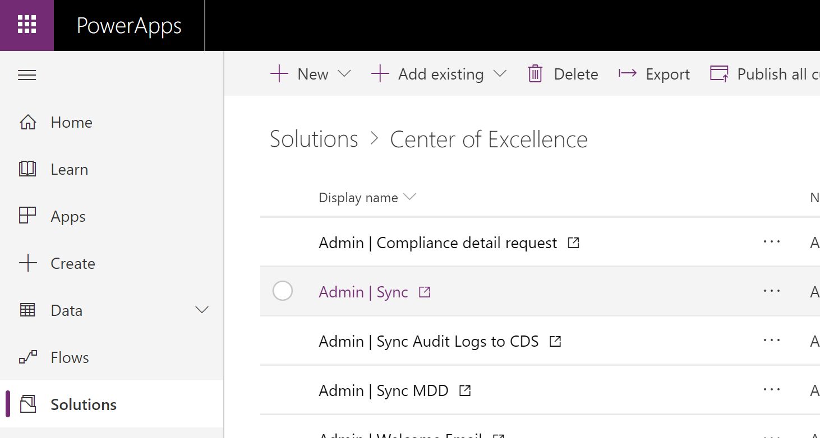
3. Click on the More (…) menu in the top right corner of the screen, select **Save As**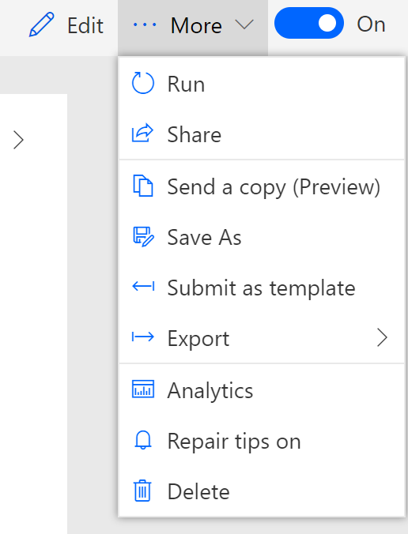
4. A window will popup saying, “We’ll create these connections for you”. Click Continue.  
   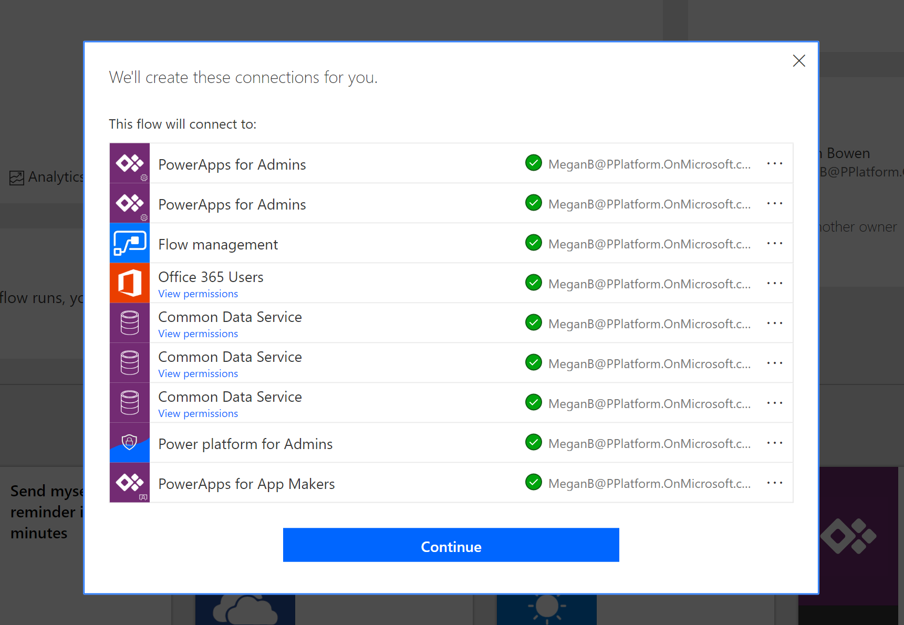
5. Rename the copy if desired. Click **Save**.   
   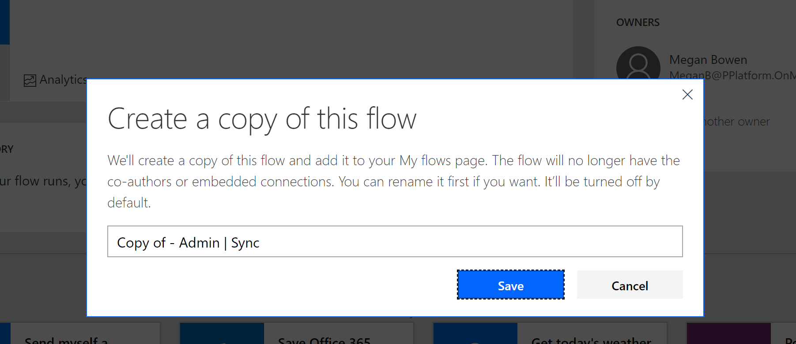
6. At this point, the copy has been created. You can view the Flow in the **Flows** page in the left navigation.
7. (Admin | Sync) Turn on the Flow, then manually run it. The time the Flow runs will depend on how many resources there are in your tenant. The Microsoft tenant has around 6,000 Environments, >20K PowerApps and >20K Flows, ~1K Custom Connectors, and ~4K makers, and this Flow took up to 24 hours to complete.

## Step 4: Configure the Power BI Dashboard

### Instructions

1. Get the organization URL
   1. Go to the Power Platform Admin Center (<https://aka.ms/ppac>)
   2. Click on Environments, and select the Environment where the Center of Excellence solution is installed
   3. Copy the organization URL in the details window.

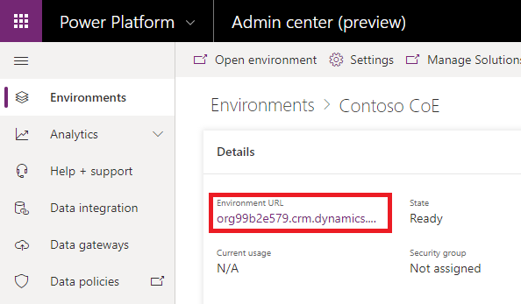

* 1. If the URL is cut off, you can see the full URL by clicking See all > Environment URL

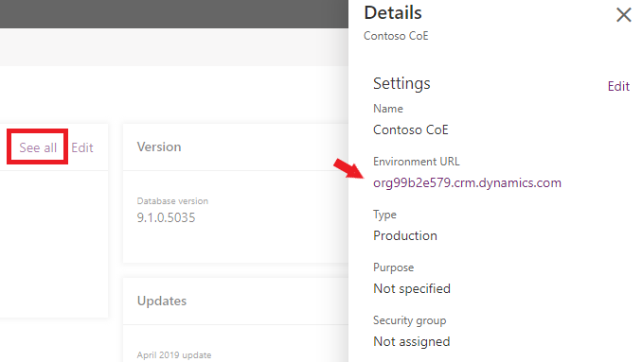

1. Open the **PowerPlatformAdminDashboard.pbix** file in the Power BI desktop application.
2. Sign-in to your account that has access to the entities.
3. Go to **Edit Query** in the top ribbon (under Home).

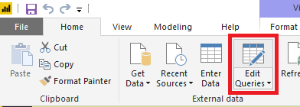

1. Select a table in the left navigation (e.g., Environments, then click on **Advanced Editor** in the top ribbon.

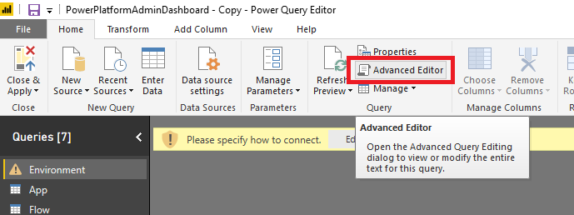

1. Replace the URL with the organization instance name, then click **Done**.

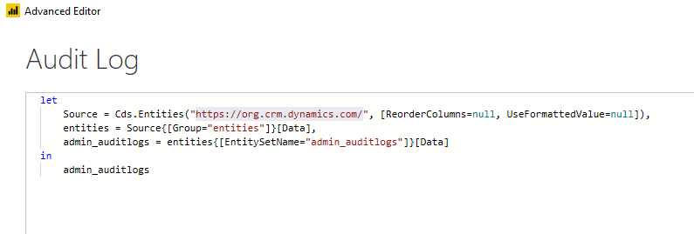

1. Click Edit Credentials

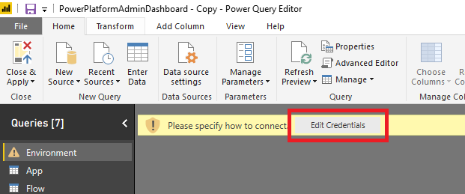

1. Sign-in to your Organizational account. Once signed in, click **Connect**.
2. A preview of the data will load into your table.

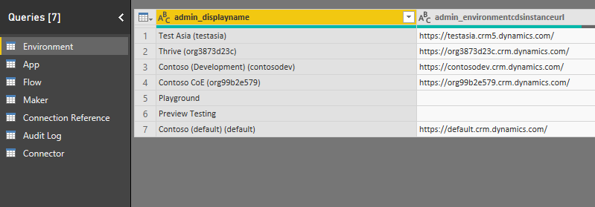

1. Repeat steps 5 and 6 for all the tables. They should not need sign-in again.
2. Click **Close & Apply**.

## Step 5: Setup Audit Log sync

### Components covered

* Custom Connector: Office 365 Logs
* Flow: Sync | Audit Logs

### Depends on

Step 1: Solution is installed

### Dependencies

Audit Log data is populated with this step. It’s option, but the Sessions information will show up as blank in the Power BI dashboard.

### Instructions

1. Install the custom connector
   1. Go to <https://flow.microsoft.com> and set the current Environment to the same Environment where the Center of Excellence solution is installed.
   2. In the left navigation, expand Data and click Custom Connectors
   3. Click on New
2. Create a connection to the custom connector
3. Instantiate the Solution Aware Flow called **Sync | Audit Logs** and run it. It will sync data to the Audit Log CDS entity.